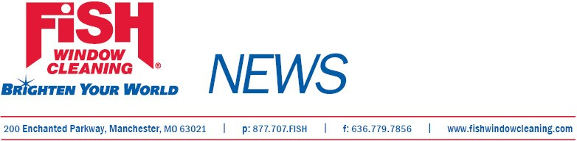
For Immediate Release

Local Businessman Named
To College Hall of Fame

November 28, 2011, St. Louis, Mo.--Leon Chadwick, owner of Fish Window Cleaning®, Duncanville, Texas, is a 2011 inductee into the Hall of Fame for Ferrum College, Ferrum, Va.
Chadwick played for the Ferrum College team, which won the 1977 National Junior College Athletic Association Championship, and he also was named to the 1978 All-American First Team. Chadwick was a starting wide receiver for Georgia Tech in 1979 and 1980, and later played for the Memphis Showboats of the United States Football League and signed with the Dallas Cowboys as a free agent in 1981.
Before opening his Fish Window Cleaning franchise in 2009, Chadwick worked in operations management for Bank of America and Wells Fargo.
Chadwick’s company provides window cleaning services to commercial and residential customers in DeSoto, Lancaster, Duncanville and Cedar Hill, Texas.
Fish Window Cleaning is the largest window cleaning company in the country. The organization ranked 139th on Entrepreneur Magazine’s 2011 Franchise 500, 61st on the 2011 AllBusiness AllStars Franchise 300, 30th among the Top 50 Large Systems in Franchise Business Review’s 2011 Franchisee Satisfaction Awards, and was named to the 2011 Inc. 5000 list of fastest growing businesses.
# # #
Contact: GeGe Mix, gege@fishwindowcleaning.com; 314-707-0896

